Name**: Mahmoud Ahmed Balabel**

B.N: **12**

SEC: **38** Date: **4/6/2021**

Topic: **Artificial Intelligence**

Application brief: I loved presenting this report on “Artificial Intelligence” because of its importance. No one can denies that artificial intelligence is a language to embody the future and create things that develop our world amazingly by investing human capabilities & technology together.

Screen shots:

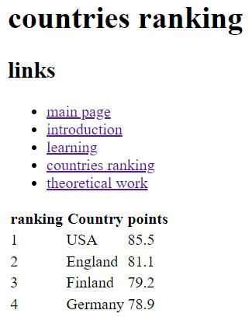



Source code: 